**CHAPTER 1**

**INTRODUCTION**

**1.1 SCOPE AND OBJECTIVE**

* To reduce paperwork.
* To make storage information more efficient and secure.
* To have a user friendly interface.
* To operate it easily and with minimum experience.
* To save time and energy of the admin.
* Easy to back up the data.

**1.2 INTRODUCTION TO SYSTEM**

The main of this system is to develop online mentor management system by using php language. This system mainly reduces the work task and it is easy to maintain the records for a long time than normal hand written records. The user can check his record details by just entering his name no need to search all the record. With the help of this system we can get the students information very easily. So the maintenance and management became very easy.

Using this systemyou can manage the student performance details throughout the academic year. The OBE based mentor system provides the easiest way to manage the details of the student by the particularly assigned mentor and head of department (HOD).

Nowadays if a student wants to know some marks or any information he should spend his time by going near subject teacher. To overcome this problem our project system provides a easiest way for student and mentor to get information quickly and time saving. Through this project system one can access the complete information about the student such as personal details, marks, co-curricular activities, attendance, participation in NCC and NSS activities etc.

**CHAPTER 2**

**SYSTEM ANALYSIS**

**2.1 Existing system**

In the existing system, the manual process, receiving data’s from student’s details are done through manual records. These records are entered in manual process. In this process will take long time, separate workers need to maintaining the databases. All the student details are stored via separate databases. It will take long time due to this process it is waste of time, money waste etc...

**Limitations of Existing System:**

* Complex and time consuming work.
* Maintaining and updating the database is difficult.
* Searching information of a particular student is quite difficult.

**2.2 Proposed System**

The main objective of the existing system is to provide a user-friendly interface. The system, which is proposed, now computerizes all the details that are maintained manually. Once the details are fed into the computer there is no need for various persons to deal with separate sections. Only a single person is enough to maintain all the reports. The security can also be given as per the requirement of the user.

**Advantages of the proposed system**

* Large volumes of data can be stored with case.
* Maintenance of file is flexible.
* Records stored are updated now and then.
* Stored data and procedures can be easily edited.
* Reports can be generated with case.
* Accurate calculations are made.
* Less manpower require
* SMS will be sent to the students parents.
* All the information about student marks, attendance etc. is available at a single

place.

**CHAPTER 3**

**SOFTWARE REQUIREMENT AND SPECIFICATIONS**

A software requirements specification (SRS) is a description of a [software system](http://en.wikipedia.org/wiki/Software_system) to be developed, laying out [functional](http://en.wikipedia.org/wiki/Functional_requirement) and [non-functional requirements](http://en.wikipedia.org/wiki/Non-functional_requirements), and may include a set of [use cases](http://en.wikipedia.org/wiki/Use_case) that describe interactions the users will have with the software.

Software requirements specification establishes the basis for an agreement between customers and contractors or suppliers (in market-driven projects, these roles may be played by the marketing and development divisions) on what the software product is to do as well as what it is not expected to do. Software requirements specification permits a rigorous assessment of requirements before design can begin and reduces later redesign. It should also provide a realistic basis for estimating product costs, risks, and schedules.

The software requirements specification document enlists enough and necessary requirements that are required for the project development. To derive the requirements we need to have clear and thorough understanding of the products to be developed or being developed. This is achieved and refined with detailed and continuous communications with the project team and customer till the completion of the software.

**3.1 Functional Requirements**

A functional requirement document defines the functionality of a system or one of its subsystems. It also depends upon the type of software, expected users and the type of system where the software is used. Functional user requirements may be high-level statements of what the system should do but functional system requirements should also describe clearly about the system services in detail.

**3.2 Non- Functional Requirements**

Non-functional requirements are constraints that must be adhered to during development. They limit what resources can be used and set bounds on aspects of the software’s quality. One of the most important things about non-functional requirements is to make them verifiable. The verification is normally done by measuring various aspects of the system and seeing if the measurements confirm to the requirements.

Non-functional requirements are divided into several groups:

The first group of categories reflects the five qualities attributes

* **Usability:** The application which we are developing is going to be used by the customer or the stakeholders. This is going to help them in predicting order of processing books.
* **Efficiency**: Our application takes less time to accomplish a particular task such as placing orders which also reduces time complexity. It reduces the complications when an information has several functionalities thus increases the efficiency.
* **Reliability:** The application that we are developing is designed to deliver set of services as expected by the user. The application provides many modules and each module is developed satisfy the non-functional requirements of the customers.
* **Maintainability**: The application that we are developing is going to provide a high performance measures such as the data updates are done automatically without loss of data that already exists.

These requirements constrain the design to meet specified levels of quality.

The second group of non-functional requirements categories constrains the environment and technology of the system.

**Other Requirements**

The software is such that as the time goes by the need of the garment industry management, agencies may keep on changing thus it is made to change from time to time.

**CHAPTER 4**

**SYSTEM DEVELOPMENT METHODOLOGY**

System development method is a process through which a product will get completed or a product gets rid from any problem. Software development process is described as a number of phases, procedures and steps that gives the complete software. It follows series of steps which is used for product progress. The development method followed in this project is waterfall model.

In this project we have 3 modules. They are

**4.1 HOD Module**

The function of HOD module is to control the overall flow and structure of administration and he also can view all the information of mentors and students, the admin should add the mentor and the admin should assign the student to the mentor.The admin can also give the feedback to the mentor on the particular student.

**4.2 Mentor Module**

The function of Mentor module is to enter the IA marks, Sem Marks, CGPA, Attendance and Co-Curricular activities of each Students which is assigned to a particular mentor. If there is a attendance shortage below 60% the mentor should send the sms to the students particular parents. If the student’s progress is low, the mentor gives the advice to their batch.

**4.3 Student Module**

The function of Student module is register first and then they can add the personal details and then they can view the marks(IA,SEM), CGPA, Co-Curricular Activities and Attendance. They can also view their profile.

**4.4 Use case Diagram of the system**

A use case diagram is a type of behavioral diagram created from a [Use-case analysis](http://en.wikipedia.org/wiki/Use-case_analysis). Its purpose is to present a graphical overview of the functionality provided by a system in terms of [actors](http://en.wikipedia.org/wiki/Actor_(UML)), their goals (represented as [use cases](http://en.wikipedia.org/wiki/Use_case)), and any dependencies between those use cases.

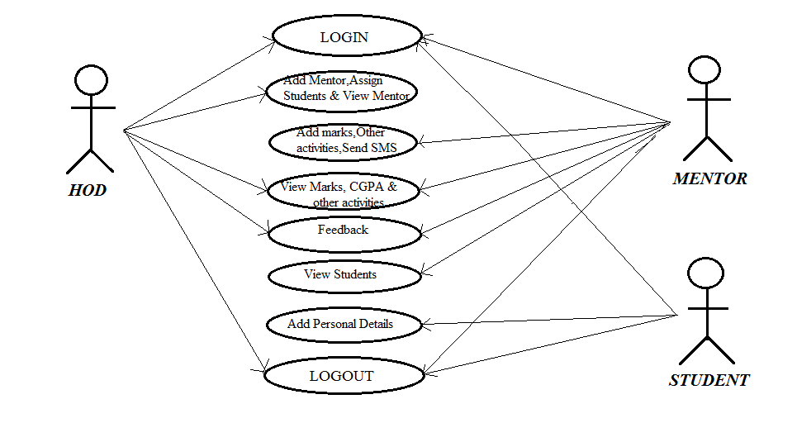

**4.5 Sequence diagram of system operation**

A sequence diagram in [Unified Modeling Language](http://en.wikipedia.org/wiki/Unified_Modeling_Language) (UML) is a kind of [interaction diagram](http://en.wikipedia.org/wiki/Interaction_diagram) that shows how processes operate with one another and in what order. It is a construct of a [Message Sequence Chart](http://en.wikipedia.org/wiki/Message_Sequence_Chart).

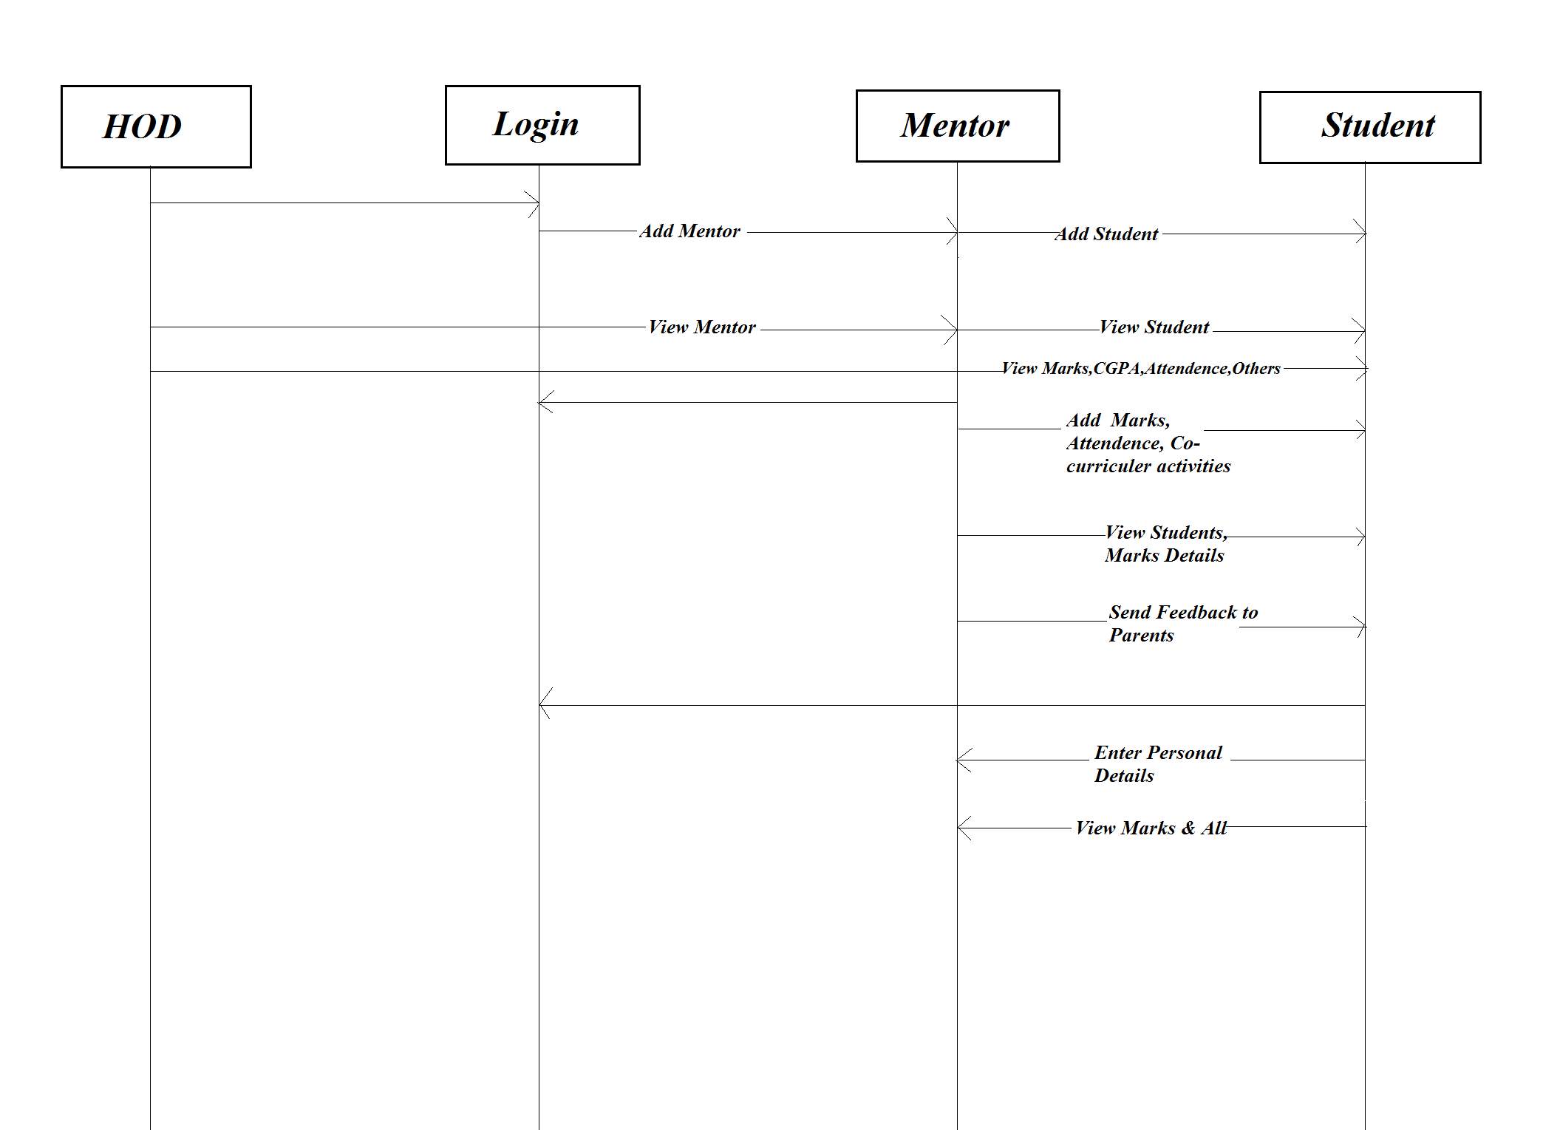

**4.6 High Level Designs**

**4.6.1 Data Flow Diagram of the system**

A data-flow diagram (DFD) is a graphical representation of the "flow" of data through an information system. DFDs can also be used for the visualization of data processing (structured design). On a DFD, data items flow from an external data source or an internal data store to an internal data store or an external data sink, via an internal process.

**Level 0 Data flow diagram**

A context-level or level 0 data flow diagram shows the interaction between the system and external agents which act as data sources and data sinks. On the context diagram (also known as the Level 0 DFD) the system's interactions with the outside world are modeled purely in terms of data flows across the system boundary. The context diagram shows the entire system as a single process, and gives no clues as to its internal organization

**Level 1 Data flow diagram**

The Level 1 DFD shows how the system is divided into sub-systems (processes), each of which deals with one or more of the data flows to or from an external agent, and which together provide all of the functionality of the system as a whole. It also identifies internal data stores that must be present in order for the system to do its job, and shows the flow of data between the various parts of the system

**4.6.2 Flow Chart diagram of system operation**

A flowchart is a type of [diagram](https://en.wikipedia.org/wiki/Diagram) that represents an [algorithm](https://en.wikipedia.org/wiki/Algorithm), [workflow](https://en.wikipedia.org/wiki/Workflow) or process, showing the steps as boxes of various kinds, and their order by connecting them with arrows. This diagrammatic representation illustrates a solution model to a given [problem](https://en.wikipedia.org/wiki/Problem_solving). Flowcharts are used in analyzing, designing, documenting or managing a process or program in various fields.

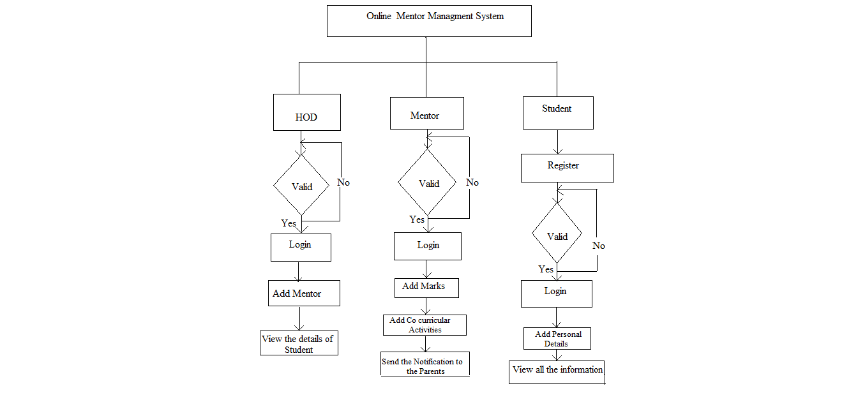

**4.6.3 Activity diagram of system operation**

Activity diagrams are graphical representations of [workflows](https://en.wikipedia.org/wiki/Workflow) of stepwise activities and actions with support for choice, iteration and concurrency. In the [Unified Modeling Language](https://en.wikipedia.org/wiki/Unified_Modeling_Language), activity diagrams are intended to model both computational and organizational processes (i.e. workflows).Activity diagrams show the overall flow of control.

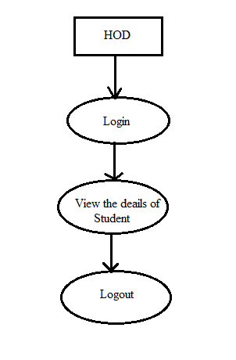

Figure: Shows the DFD of HOD

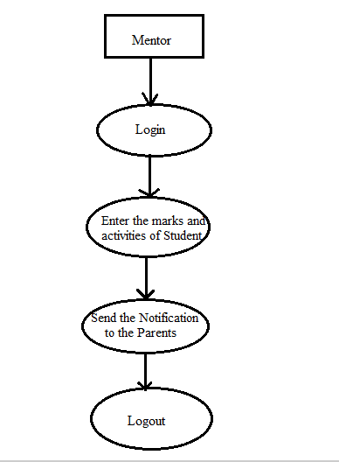

Figure: Shows the DFD of Mentor

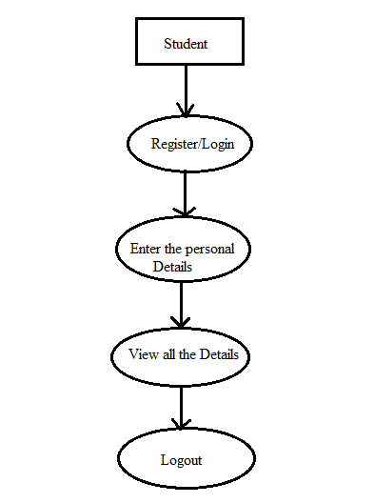

Figure: Shows the DFD of Student

**CHAPTER 5**

**HARDWARE AND SOFTWARE REQUIREMENTS**

To be used efficiently, all [computer software](https://en.wikipedia.org/wiki/Computer_software) needs certain [hardware](https://en.wikipedia.org/wiki/Computer_hardware) components or other software resources to be present on a [computer](https://en.wikipedia.org/wiki/Computer).These prerequisites are known as (computer) systemrequirements and are often used as a guideline as opposed to an absolute rule. Most software defines two sets of system requirements: minimum and recommended. With increasing demand for higher processing power and resources in newer versions of software, system requirements tend to increase over time. Industry analysts suggest that this trend plays a bigger part in driving upgrades to existing computer systems than technological advancements. A second meaning of the term of System requirements is a generalization of this first definition, giving the requirements to be met in the design of a system or sub-system. Typically an organization starts with a set of Business requirements and then derives the System requirements from there.

**5.1 HARDWARE REQUIREMENTS**

* Processor - Pentium III and above
* Speed - 1.1 Ghz min
* Hard Disk - 20 GB

**5.2 SOFTWARE REQUIREMENTS**

* Operating System - Windows
* Programming Language - PHP,HTML, CSS ,BOOTSTRAP
* Storage - My sql

**CHAPTER 6**

**IMPLIMANTATION**

**Source code: INDEX.PHP**

<! DOCTYPE html>

<html>

<head>

<title>Online Mentor Management</title>

<!--css-->

<link href="css/bootstrap.css" rel="stylesheet" type="text/css" media="all" />

<link href="css/style.css" rel="stylesheet" type="text/css" media="all" />

<link rel="stylesheet" href="css/ken-burns.css" type="text/css" media="all" />

<link rel="stylesheet" href="css/animate.min.css" type="text/css" media="all" />

<!--css-->

<meta name="viewport" content="width=device-width, initial-scale=1">

<meta http-equiv="Content-Type" content="text/html; charset=utf-8" />

<meta name="keywords" content="Studies Plus Responsive web template, Bootstrap Web Templates, Flat Web Templates, Android Compatible web template,

Smartphone Compatible web template, free webdesigns for Nokia, Samsung, LG, Sony Ericsson, Motorola web design" />

<script type="application/x-javascript"> addEventListener("load", function() { setTimeout(hideURLbar, 0); }, false); function hideURLbar(){ window.scrollTo(0,1); } </script>

<!--js-->

<script src="js/jquery.min.js"></script>

<script src="js/bootstrap.min.js"></script>

<!--js-->

<!--webfonts-->

<link href='//fonts.googleapis.com/css?family=Cagliostro' rel='stylesheet' type='text/css'>

<link href='//fonts.googleapis.com/css?family=Open+Sans:400,300,300italic,400italic,600,600italic,700,700italic,800,800italic' rel='stylesheet' type='text/css'>

<!--webfonts-->

</head>

<body>

<!--header-->

<div class="header">

<div class="container">

<nav class="navbar navbar-default">

<div class="container-fluid">

<!---Brand and toggle get grouped for better mobile display--->

<div class="navbar-header">

<button type="button" class="navbar-toggle collapsed" data-toggle="collapse" data-target="#bs-example-navbar-collapse-1" aria-expanded="false">

<span class="sr-only">Toggle navigation</span>

<span class="icon-bar"></span>

<span class="icon-bar"></span>

<span class="icon-bar"></span>

</button>

<div class="navbar-brand">

<h1><a href="#">Mentor Management</a></h1>

</div>

</div>

<!-- Collect the nav links, forms, and other content for toggling -->

<div class="collapse navbar-collapse" id="bs-example-navbar-collapse-1">

<nav class="link-effect-2" id="link-effect-2">

<ul class="nav navbar-nav">

<li class="active"><a href="index.html"><span data-hover="Home">Home</span></a></li>

<li><a href="Adminlogin.php"><span data-hover="Hod">Hod</span></a></li>

<li><a href="Mentorlogin.php"><spandatahover="Mentor">Mentor</span>

</a></li>

<li><a href="studentRegistration.php"><span datahover="Students">Students</span>

</a></li>

</ul>

</nav>

</div>

</div>

</nav>

</div>

</div>

<!--header-->

<!-- banner -->

<div class="banner">

<div id="kb" class="carousel kb_elastic animate_text kb_wrapper" data-ride="carousel" data-interval="6000" data-pause="hover">

<!-- Wrapper-for-Slides -->

<div class="carousel-inner" role="listbox">

<!-- First-Slide -->

<div class="item active">

<img src="images/banner.jpg" alt="" style="height:500px;" class="img-responsive" />

</div>

</div>

</div>

<script src="js/custom.js"></script>

</div>

<!--banner-->

<!---copy--->

<div class="copy-section">

<div class="container">

<div class="copy">

<p>&copy; 2018 Menor Management . All rights reserved</a></p>

</div>

</div>

</div>

<!---copy--->

</body>

</html>

**CHAPTER 7**

**SCREENSHOT**

**Snapshot 1: Index page**



**Snapshot 2: Admin Login page**

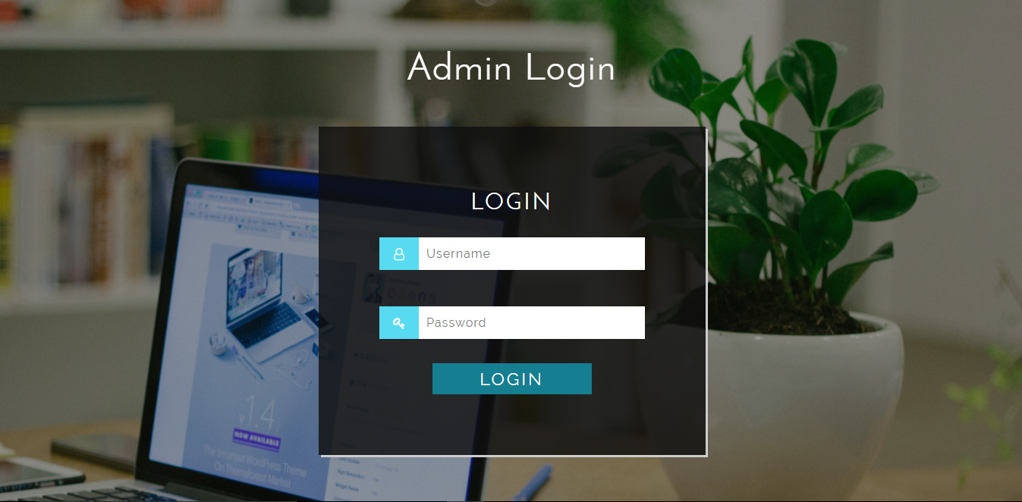

**Snapshot 3: Admin Dashboard page**



**Snapshot 4: Mentor Login page**

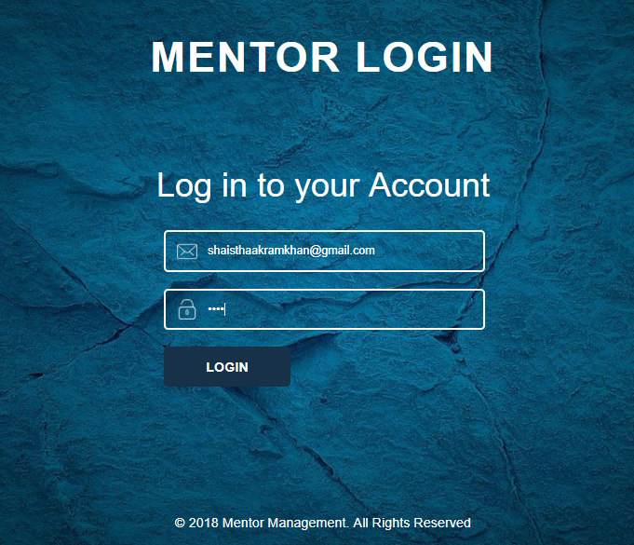

**Snapshot 5: Mentor Dashboard page**



**Snapshot 6: Student Login page**

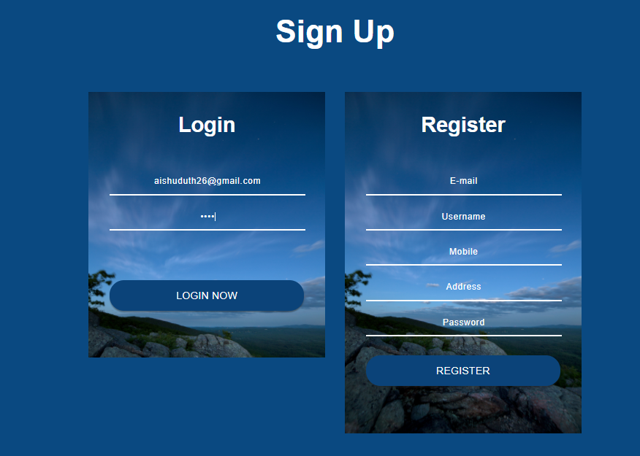

**Snapshot 7: Student Dashboard page**



**CHAPTER 8**

**SOFTWARE TESTING**

The purpose of testing is to discover errors. Testing is the process of trying to discover every conceivable fault or weakness in a work product. It provides a way to check the functionality of components, sub-assemblies, assemblies and/or a finished product It is the process of exercising software with the intent of ensuring that the

Software system meets its requirements and user expectations and does not fail in an unacceptable manner. There are various types of test. Each test type addresses a specific testing requirement.

Functional tests provide systematic demonstrations that functions tested are available as specified by the business and technical requirements, system documentation, and user manuals.

Functional testing is centered on the following items:

Valid Input : identified classes of valid input must be accepted.

Invalid Input : identified classes of invalid input must be rejected.

Functions : identified functions must be exercised.

Output : identified classes of application outputs must be exercised.

Systems/ Procedures: interfacing systems or procedures must be invoked.

Organization and preparation of functional tests is focused on requirements, key functions, or special test cases. In addition, systematic coverage pertaining to identify Business process flows; data fields, predefined processes, and successive processes must be considered for testing. Before functional testing is complete, additional tests are identified and the effective value of current tests is determined.

**Test Cases**

|  |  |  |  |  |  |  |  |
| --- | --- | --- | --- | --- | --- | --- | --- |
| Test case ID | Test case name | Test case description | Test steps | | | | Test status P/F |
| Step | I/p given | Expected o/p | Actual o/p |
| TC01 | Admin Login | To verify that the  User has entered  Valid username and password | Login with  Username & password | Valid Username & password | Login successful | Login successful | Pass |
| Admin  Login | To verify that the User  has entered  Valid username and password | Login with  Username & password | Invalid Username &  password | Login successful | Error Enter valid  Username & password | Fail |
| TC02 | Registration | To verify that the user has registered by entering valid details | Enter all the valid user details | Valid details | Registered  successfully | Registered  Successfully | Pass |
|  | Registration | To verify that the user has registered by entering valid details | Enter all the valid user details | InValid details | Registered  successfully | Not Registered  Successfully | Fail |
| TC03 | Mentor Login | To verify that the  User has entered  Valid username and password | Login with  Username & password | Valid UserName & Password | Login successful | Login successful | Pass |
|  | Mentor  Login | To verify that the User  has entered  Valid username and password | Login with  Username & password | Invalid Username &  Password | Login successful | Error Enter valid  Username & password | Fail |
| TC04 | Student Login | To verify that the  User has entered  Valid username and password | Login with  Username & password | Valid Username & Password | Login successful | Login successful | Pass |
|  | Student  Login | To verify that the User  has entered  Valid username and password | Login with  Username & password | Invalid Username &  Password | Login successful | Error Enter valid  Username & password | Fail |

**CONCULSION**

This paper assists in modifying the existing system to site based system .This is a paperless work. It can be monitored and controlled remotely. It reduces the manpower required. It provides accurate information always. All gathered and extra information can be saved and can be accessed at any time. The data which is stored in the project helps in taking intelligent and quick decisions by the management. So it is better to have a Web-Based Information Management system.

**FUTURE ENHANCEMENT**

This project helps for all the students, lecturers and Head of the department. This processes can be done through online easily. Using this project it is very easy to handle student development in college. This system is beneficial for both students and College as they can get all previous or current information when they need. This system is also helpful to maintain the student’s record like attendance, exam result records, personal details, co-curricular activities. Student management system can help to get all or a particular student detail information.  Also it can help to maintain the Student in proper way.

**REFERENCES**

* Mobile App Development, http://www.

rapidsofttechnologies.com/android-applicationdevelopment.html

* Android, MySQL, PHP, &JSON, http://www.

mybringback.com/tutorial-series/12924/android-tutorialusing-remote-databases-php-and-mysql/.

* www.w3schools.com